

Software Requirements Specification Document

--iMovie Web Application



August 31st, 2017

TEAM 36:

Andrew

Jichen ZHAO

Meng YUAN

Nelson

Xuan WEI

[1 Introduction 2](#_Toc491954250)

[2 Website Wireframes 3](#_Toc491954251)

[2.1 Sign Up Page 3](#_Toc491954252)

[2.2 Register Page 3](#_Toc491954253)

[2.3 Forget Password Page 4](#_Toc491954254)

[2.4 Administrator Homepage for Activities Management 4](#_Toc491954255)

[2.5 Administrator Homepage for Adding an Activity Function 5](#_Toc491954256)

[2.6 Administrator Homepage for Movies Management 5](#_Toc491954257)

[2.7 Administrator Homepage for Adding a Movie Function 6](#_Toc491954258)

[2.8 Administrator Homepage for Editing Movie Function 6](#_Toc491954259)

[2.9 Administrator Homepage for User management 7](#_Toc491954260)

[2.10 Administrator Homepage for View Personal Information Function 7](#_Toc491954261)

[2.11 User Homepage for Personal Information 8](#_Toc491954262)

[2.12 User Homepage for Updating Personal Information Function 8](#_Toc491954263)

[2.13 User Homepage for Viewing Their Comments Function 9](#_Toc491954264)

[2.14 User Homepage for Editing Comment Function 9](#_Toc491954265)

[2.15 User Homepage for Viewing Responded Activity function 10](#_Toc491954266)

[2.16 User Homepage for Booking Activity Function 10](#_Toc491954267)

[2.17 User Homepage for Viewing Activity Function 11](#_Toc491954268)

[2.18 Administrator Homepage for Blocking User Account Function 11](#_Toc491954269)

[2.19 Homepage 12](#_Toc491954270)

[2.20 Movie View Page 12](#_Toc491954271)

[2.21 Movie List Page 13](#_Toc491954272)

[2.22 Movie Ranking Page 13](#_Toc491954273)

[2.23 Activity Page 14](#_Toc491954274)

[3 Use Case 15](#_Toc491954275)

[4 Nonfunctional Requirements 32](#_Toc491954276)

[5 Project Plan 33](#_Toc491954277)

[5.1 Staff Organization -- Role Definitions 33](#_Toc491954278)

[5.2 Time line -- Gantt Chart 34](#_Toc491954279)

[5.3 Project risk factors 34](#_Toc491954280)

[5.4 Minimum Viable Product (MVP) 35](#_Toc491954281)

[6 Constraints & Development and Target Platforms 35](#_Toc491954282)

[6.1 Constraints 35](#_Toc491954283)

[6.2 Development and Target Platforms 35](#_Toc491954284)

# 1 Introduction

Watching movies has become a popular hobby at this moment. People would like to go to the cinema or watch movies at home in leisure time. However, there are so many types of movies and they are uneven in quality. Finding favorites films effectively in a short time has become to a challenge for majority of people. A more efficient web application is required to query movie information and select movies for users.

After watching the film, people desire to communicate and share their opinions with others about it. Meanwhile, films could be interpreted in different aspects and others’ view of the movie can also broaden the thinking. Therefore, the online platform is required to review movies for users. In addition, moviegoers will get critical thoughts from the film review.

Overall, based on the demand, we decide to build a web application about movie which would provide a number of functions, such as movie searching, movie reviewing and movie recommendation, etc. This document describes the specific requirements of this web application.

# 2 Website Wireframes

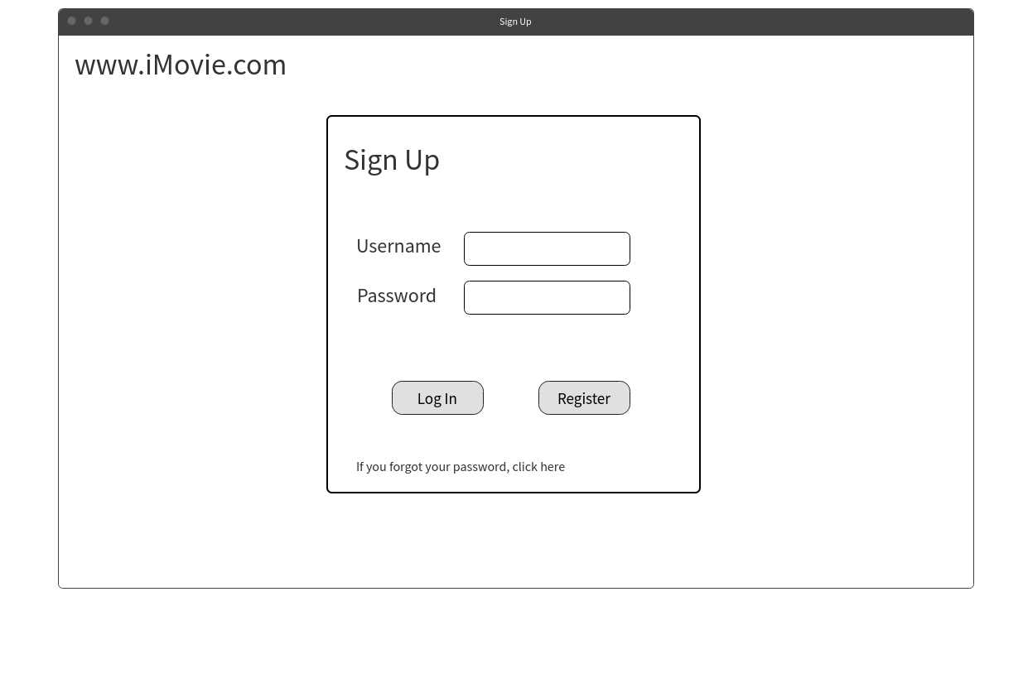2.1 Sign Up Page

2.2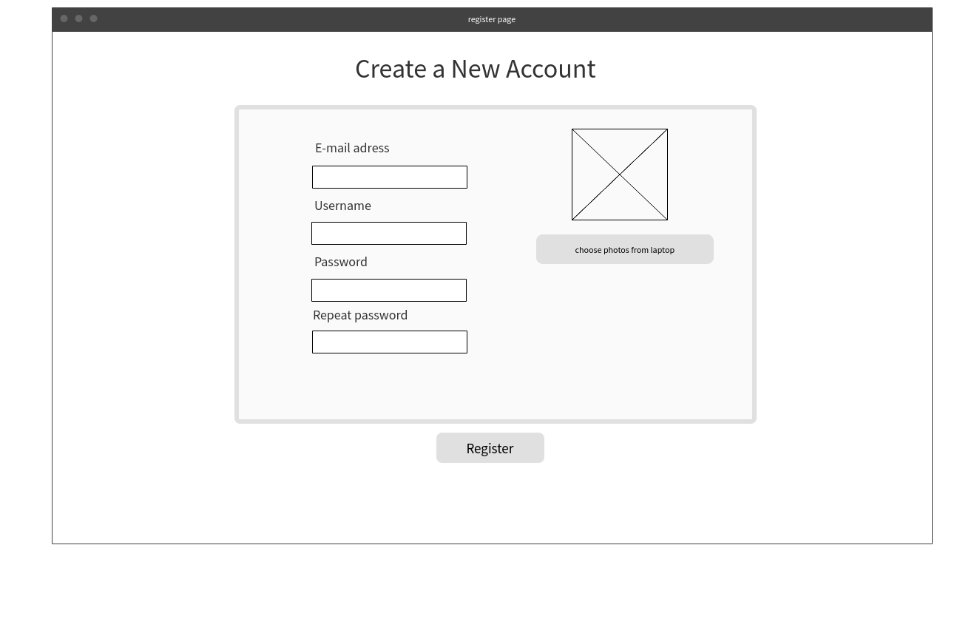 Register Page

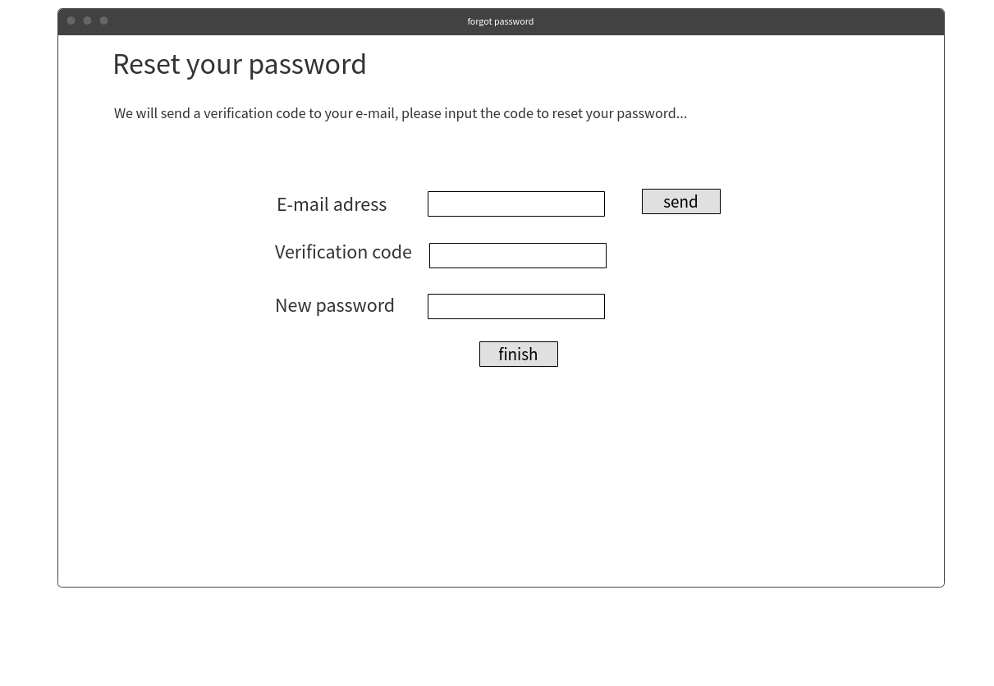2.3 Forget Password Page

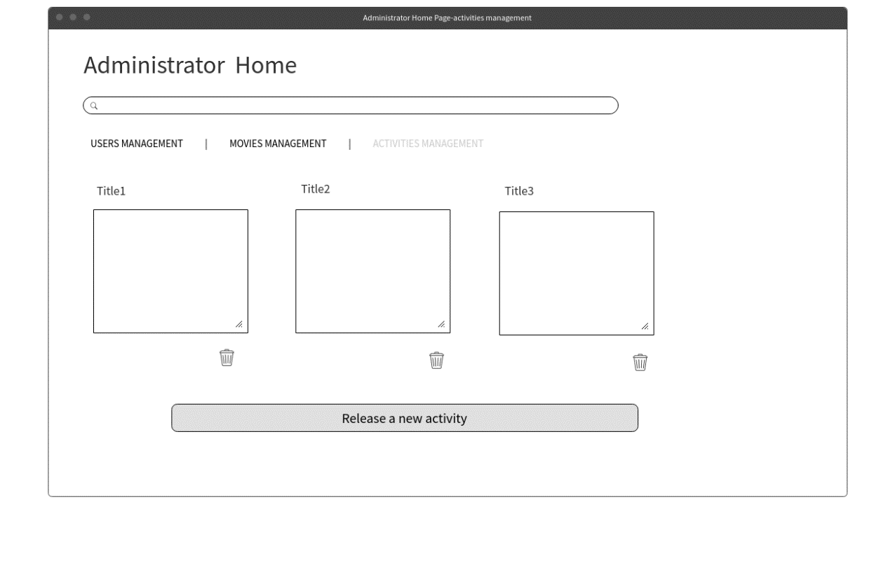2.4 Administrator Homepage for Activities Management

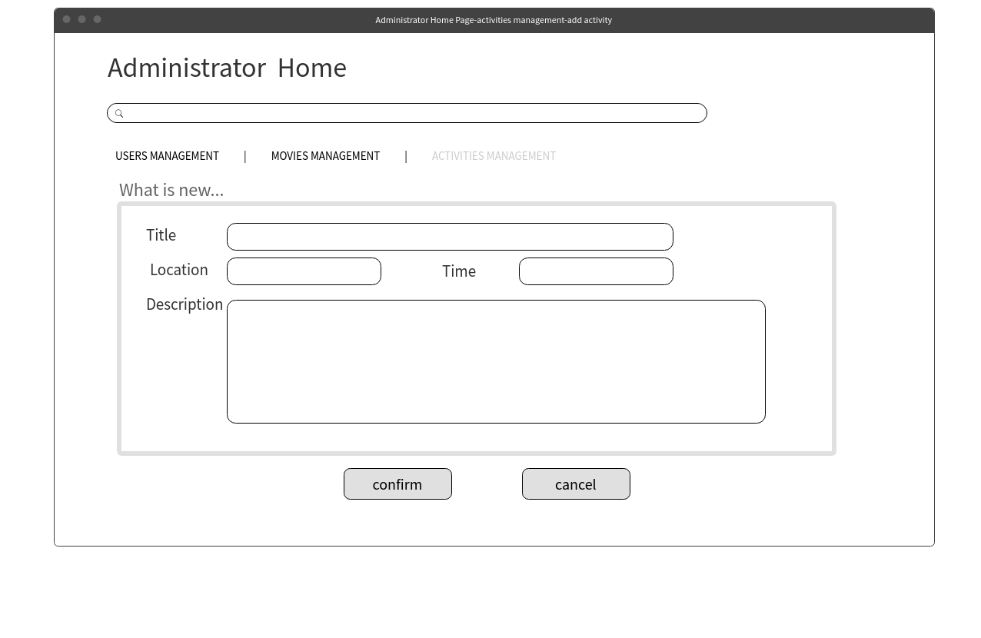2.5 Administrator Homepage for Adding an Activity Function

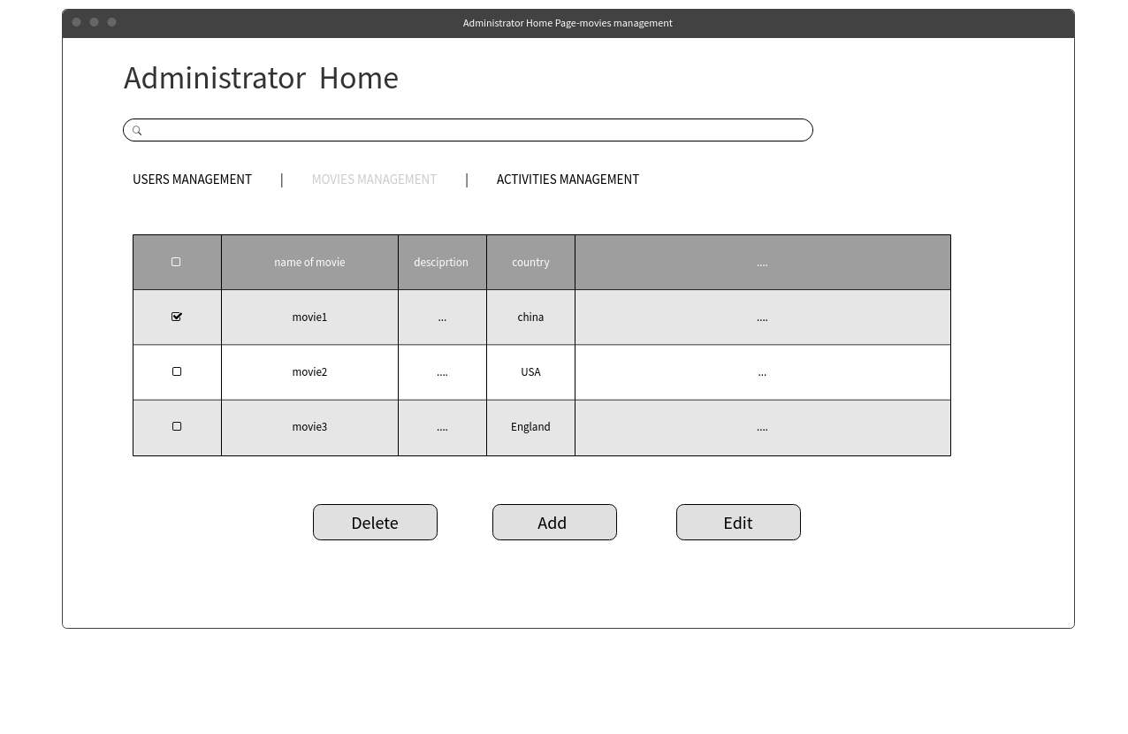2.6 Administrator Homepage for Movies Management

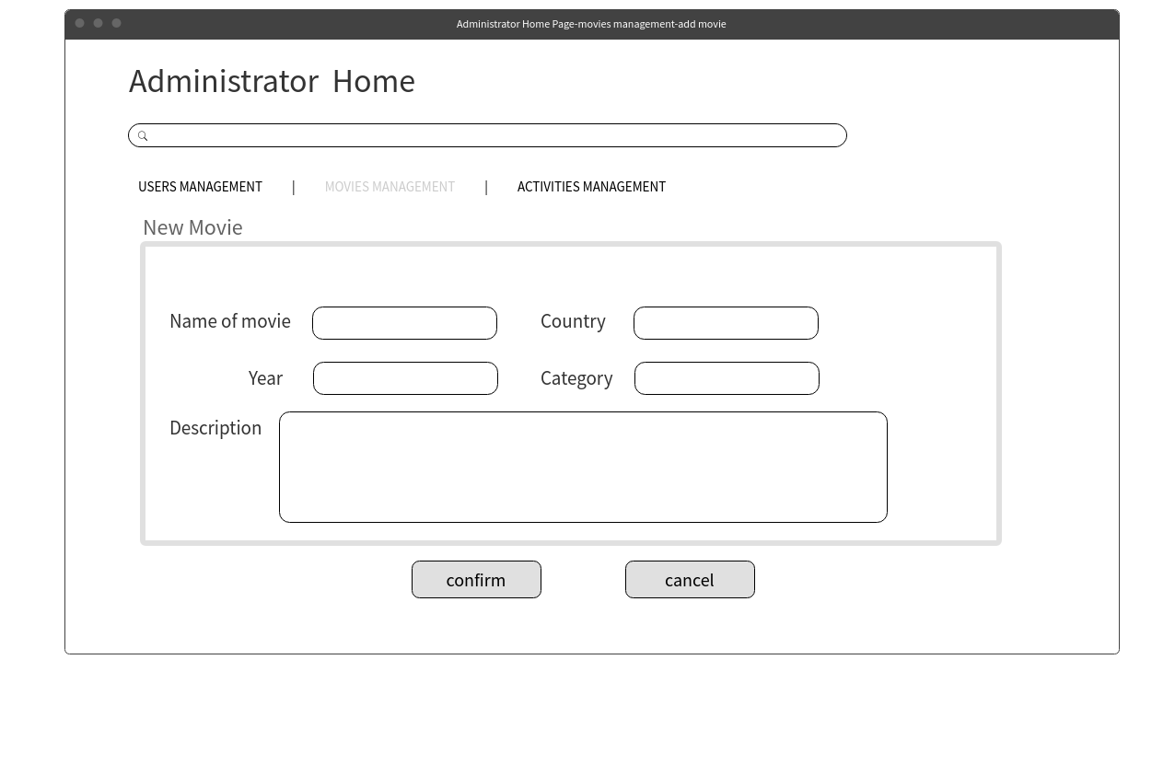2.7 Administrator Homepage for Adding a Movie Function

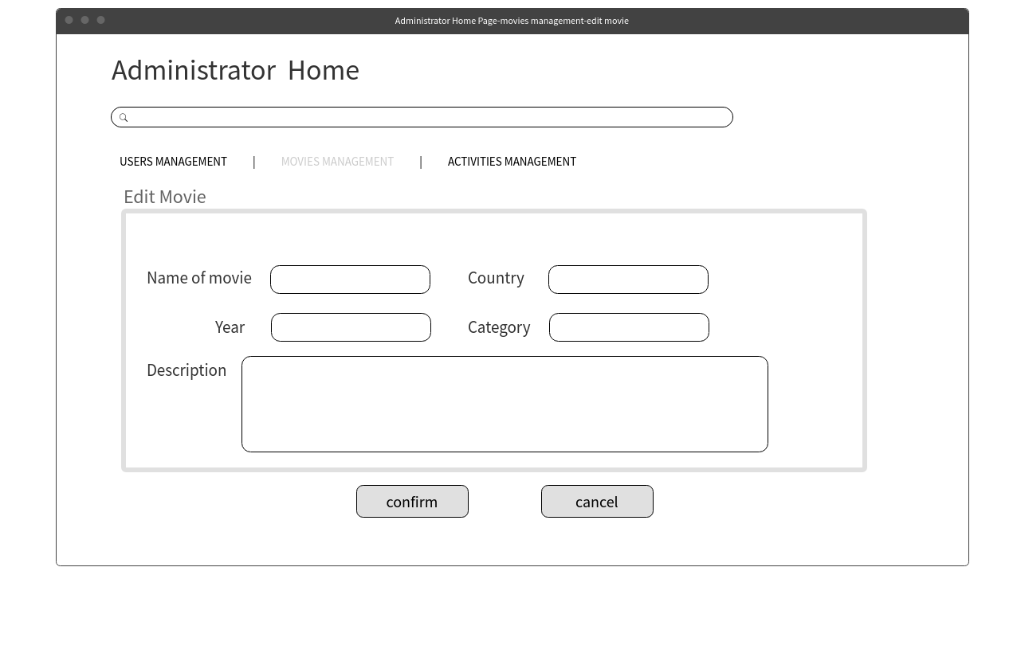2.8 Administrator Homepage for Editing Movie Function

2.9 Administrator Homepage for User management

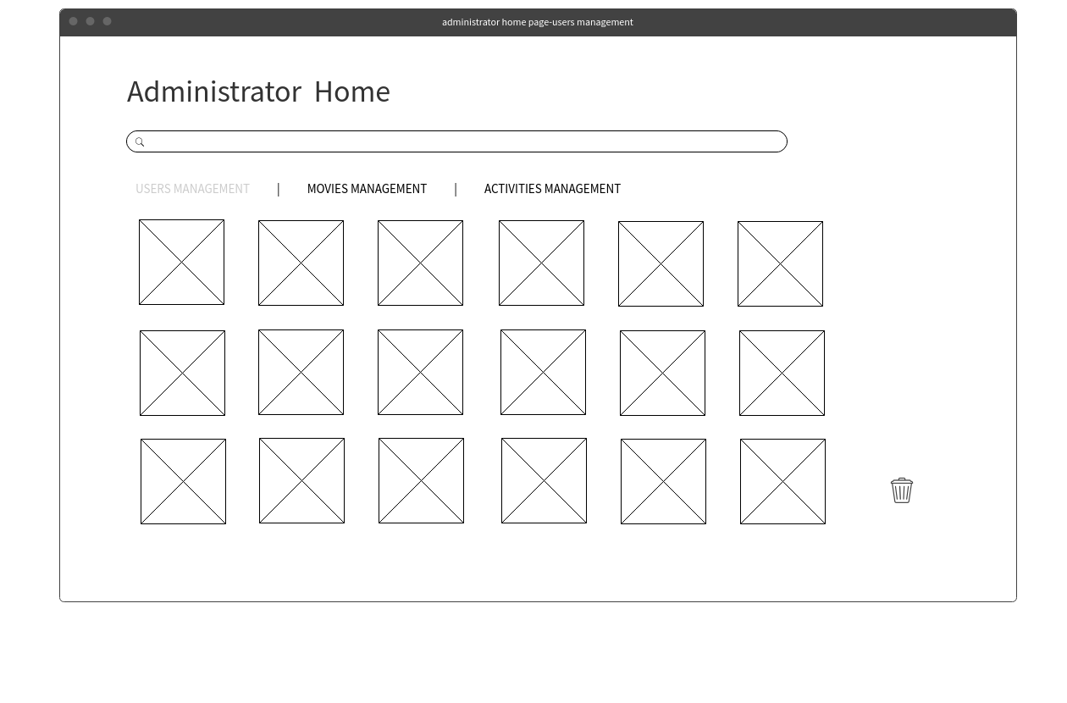

2.10 Administrator Homepage for View Personal Information Function

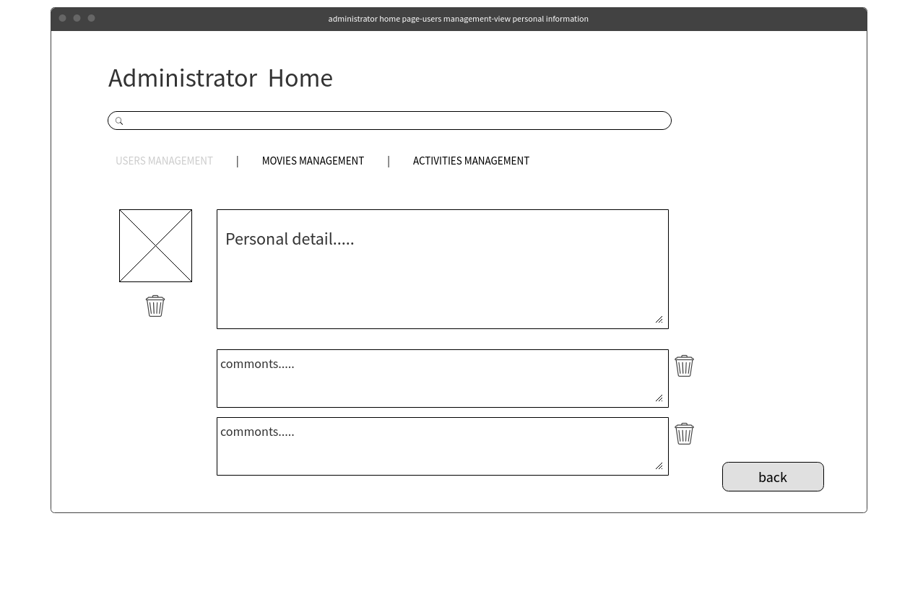

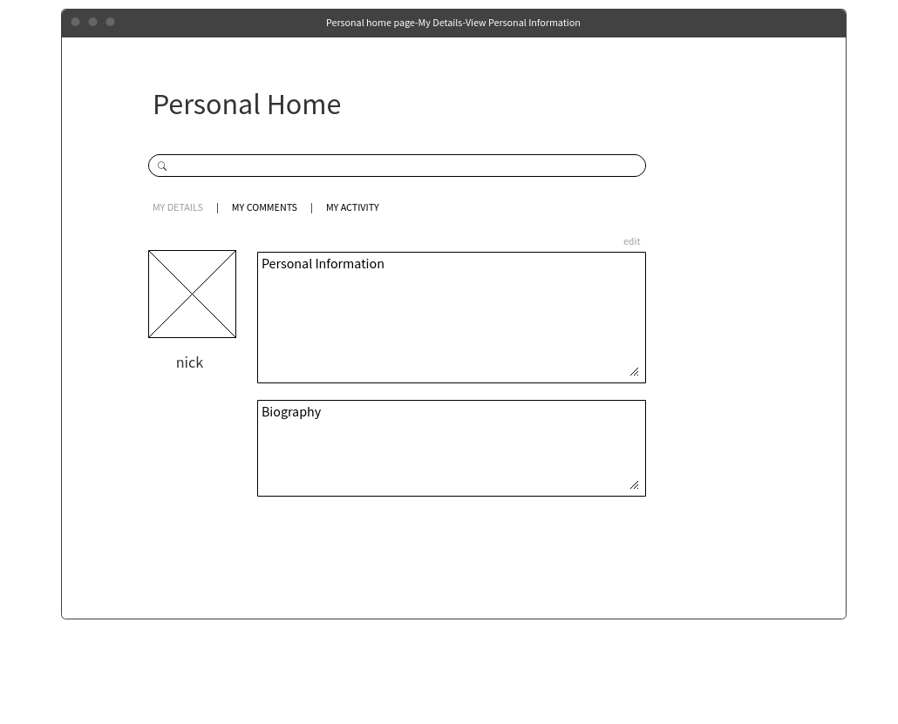2.11 User Homepage for Personal Information

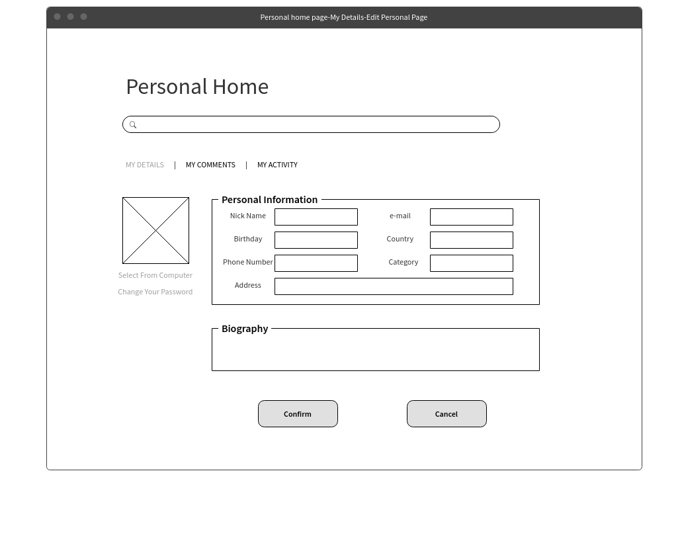2.12 User Homepage for Updating Personal Information Function

## https://lh3.googleusercontent.com/_d2fdpCzrgtPuJDmooWEX9YKK1-mVEk_ocdjNZlxQ0inoWRGLCkENohPClGK0skmGX4ovhOtTX0Gupiz9H4wWVhzADpWBp0Uw3lcVPWDuJMKlcE2nxnWtM8giCU4FFkS9ThiSPL5jfo1q8O_uA2.13 User Homepage for Viewing Their Comments Function

## https://lh6.googleusercontent.com/sfSWFB_Y0mL3RyibhUCOnHzxYzuXBe3PHVL7jbzDBb2p0_bHBnkpjs-ZQIF3oU6aeuQKdJ9MMbJpFA3IZIn49AFhQ-9jHZVicGq3JX8wxP8HALefCvwqu0PpfS7x1SR9dHJcgyONWJaVkmGOLQ2.14 User Homepage for Editing Comment Function

## https://lh5.googleusercontent.com/_qZqgmczroXNUuFir7YxCOOqEu_N_QRabK9Dajv4EfK66FRPaLH36KDqfN1nQGGvAWyyAnRuOMf_ZcTX1jafCSpiU8M9sWLowzza5vMmviw6AF1vbPx10rad1S2cD2X5yI4JwvvbaUP8xrTVSA2.15 User Homepage for Viewing Responded Activity function

## https://lh5.googleusercontent.com/XmZPKIDUJlcCWjj4LoJhHoiZC_rhdI738VNPsXpzffvLl_wrNf8-ObSGddkzJWfC19dKav8C-mYnetvbhif6zULgYAcP-Zy0C49VH4ZCQvkm9l1cv7ER5GD6C9w9i0WfYqEczGlygjbhgRLKbw2.16 User Homepage for Booking Activity Function

## https://lh5.googleusercontent.com/zHIW2r-tzYPV3LbYRsVQx0BbiLW3zb-WC2IDB8Ts3EA7rokFHlF-UMqstNdj4QXq73PGNbbUIIC2AyxQLS5Oul0LAnNDpDBIIBvwbJ62ZorIJF2NK13UIX6Fd89qnkLeeoPvxrZm2.17 User Homepage for Viewing Activity Function

## https://lh3.googleusercontent.com/KLPjGTxHnFGOti7X-hK_8vAtaU9jTb7_tvqpEcqLXwOD5zyE28L3Tf4LZefnS_OsN_rN3Vmp5lfENqX8Do_dtDdQeFuc1KMtMbMK1QL6_b9_Dz8sAXyICmB2nVBmUARPAJLhvH3m2.18 Administrator Homepage for Blocking User Account Function

## b28509b1a9574c718140c0b0d566ab3f.png2.19 Homepage

## C:\Users\00OX_X~1\AppData\Local\Temp\WeChat Files\20458555804493014.png2.20 Movie View Page

## C:\Users\00OX_X~1\AppData\Local\Temp\WeChat Files\508617322824880362.png2.21 Movie List Page

## C:\Users\00OX_X~1\AppData\Local\Temp\WeChat Files\397600142671972468.png2.22 Movie Ranking Page

## C:\Users\00OX_X~1\AppData\Local\Temp\WeChat Files\623233521129814148.png2.23 Activity Page

# 3 Use Case

Figure 1: Use case diagram for iMovie web application.

This web application could be divided into 30 use cases. Figure 1 is the use case diagram, which indicates the relationship between these use cases. All the use cases are listed as follow.

|  |  |
| --- | --- |
| Name: Create an account | ID: 1 |
| Primary Actor: User; | |
| Stakeholders and Interests: | |
| Users | Users want to use all functions of the website; |
| Administrator | administrator hope manage all enrolled  users; |
| Trigger: When users want to  enroll in the iMovie website; | |
| Normal flow: 1.Click the “sign up” button; 2.Input “your email”, “your nickname’, “your password”; 3.Upload your photo; 4.Click the “Confirm” button; 5.Pass the verification; | |
| Alternate flow:  3a. Upload the photo unsuccessfully;    3a1.  Re-upload the photo;    3a2.  Go back to step3; 5a. Not pass the verification;    5a1. Check the nickname, email and password;    5a2. Go back to step2; | |

|  |  |
| --- | --- |
| Name: Block User’s Accounts | ID: 2 |
| Primary Actor: administrator; | |
| Stakeholders and Interests: | |
| Users | Users who do something illegal will be block; |
| Administrator | Administrator want to keep order of the website; |
| Trigger: When administrator find users’  illegal behavior; | |
| Normal flow: 1. Click the the “Personal Home” button;  2. Administrator’s home page appears;  3. The user’s photo has been list;  4. Click the user’s photo;  5. User’s personal detail is released;  6. Click “block this user” button;  7. Click the “Confirm” button;  8. The user’s account is blocked; | |
| Alternate flow:  4a. Cannot relate to personal detail;   4a1. This account has been deleted;   4a2. Go back to step3;  8a. error blocking;  8a1. Go back to step5; | |

|  |  |
| --- | --- |
| Name: Login account; | ID: 3 |
| Primary Actor: Users and Administrator; | |
| Stakeholders and Interests: | |
| Users | Users want to use the function which provided to enrolled users. |
| Administrator | Administrator hope exercise their right to manage this website. |
| Trigger: Users and Administrator  want to make use of all  function of the website | |
| Normal flow: 1. Click the “sign in” button; 2. Input “email address” and “password”; 3. Click the “Confirm” button; 4. Pass the verification | |
| Alternate flow:  4a. Not pass the verification       4a.1 Check the email and password;       4a.2 Go back to step2 | |

|  |  |
| --- | --- |
| Name: Logout account; | ID: 4 |
| Primary Actor: Users and Administrator; | |
| Stakeholders and Interests: | |
| Users | Users want to leave the website and prevent others from using personal accounts; |
| Administrator | Administrator want to leave the website and prevent others from misusing the account; |
| Trigger: Users and Administrator want to stop use part of  the function of this website; | |
| Normal flow: 1.Login;  1.Movie main page appear;  2.Click the “logout” button;  3.Account is logout; | |
| Alternate flow:  4a. Account cannot logout;     4a1. Go back to step3; | |

|  |  |
| --- | --- |
| Name: Reset Password; | ID:5 |
| Primary Actor: Users and Administrator; | |
| Stakeholders and Interests: | |
| Users | Users forget the password or want to change the passwords; |
| Administrator | Administrator need to update the password; |
| Trigger: Users and Administrator require change their personal passwords; | |
| Normal flow: 1. Click the “forgot password” button; 2. Input the email;  3.Click the “send verification code” button;  3. Check the mailbox;  4. Get the verification code in mailbox; 5. Input the verification code; 6. Input new password; 7. Re-enter new password; 8. Pass the verification | |
| Alternate flow:  4a.the verification code was not received;  4a.1 check the junk email  4a.2 go back to step 2；  5a.the new password is invalid;  5a.1 go back to step 6； | |

|  |  |
| --- | --- |
| Name: view personal information; | ID:6 |
| Primary Actor: Users and Administrator; | |
| Stakeholders and Interests: | |
| Users | Users want to know his own information on the website; |
| Administrator | Administrator want to know his own information on the website; |
| Trigger: Users and Administrator require see personal information; | |
| Normal flow: 1.Login;  1.Movie main page appear;  2.Click the “logout” button;  3.Account is logout; | |
| Alternate flow:  4a. Account cannot logout;     4a1. Go back to step3; | |

|  |  |
| --- | --- |
| Name: Update personal information | ID: 7 |
| Primary Actor: User; | |
| Stakeholders and Interests: | |
| Users | Users want to substantial in content; |
| Trigger: When users want to show their personal information and nickname. | |
| Normal flow:  1. Click the “Personal Home”;  2. Click the “Edit” button;  3. Input “Nickname”, “E-mail”, “Birthday”, “Country”, ” Phone Number”, “Category”, “Address” and “Biography”;  4. Click the “Confirm” button;  5. The personal information has been update; | |
| Alternate flow:  5a. Confirm unsuccessfully;     5a1. The nickname has been used;     5a2. Go back to step 3; | |

|  |  |
| --- | --- |
| Name: Change Password | ID: 8 |
| Primary Actor: User; | |
| Stakeholders and Interests: | |
| Users | Users may want to change their password; |
| Trigger: When user want to change their password; | |
| Normal flow: 1. Click the “Personal Home”;  2. The personal home page appears;  3. Click the “Change Your Password” button;  4. The change password page appears;  5. Input “E-mail address”;  6. Click the “Send” button;  7. Input “Verification code”, “New password”;  8. Click the “Finish” button; | |
| Alternate flow:  7a. Did not receive verification code;   7a1. Click the “Send” button again;   7a2. Go back to step 5;  8a. Finish unsuccessfully;   8a1. The verification code is wrong;   8a2. Go back to step 4; | |

|  |  |
| --- | --- |
| Name: Comment movies | ID: 9 |
| Primary Actor: User; | |
| Stakeholders and Interests: | |
| Users | Users want to comment movies; |
| Trigger: When users want to comment movies in the iMovie website; | |
| Normal flow: 1. Click a film which will be comment;  2. Click the “writing” button;  3. Input comments;  4. Click the “confirm” button;  5. The comment has been saved. | |
| Alternate flow:  5a. Confirm unsuccessfully;   5a1.The comment is none or over limited;   5a2. Go back to step 3; | |

|  |  |
| --- | --- |
| Name: View comments | ID: 10 |
| Primary Actor: User; | |
| Stakeholders and Interests: | |
| Users | Users want to view all comments for one movie; |
| Trigger: When users want to view all comments and the detail of movie; | |
| Normal flow: 1. Click the film;  2. The film’s page is appeared;  3. View comments; | |
| Alternate flow:  None | |

|  |  |
| --- | --- |
| Name: Go Back To Movie | ID: 11 |
| Primary Actor: User; | |
| Stakeholders and Interests: | |
| Users | Users want to go to comment movie which was comment; |
| Trigger: When users want to check their comments; | |
| Normal flow: 1. Click the “Personal Home” button;  2. The personal home page appears;  3. Click the “My Comments” button;  4. The comments list appears;  5. Click the “view” button;  6. Go to movie’s comment page; | |
| Alternate flow:  1a. Cannot find “Personal Home” button;    1a1. User did not login;    1a2. Go back to login page;  6a. Cannot go back to movie;    6a1. Go back to step 4; | |

|  |  |
| --- | --- |
| Name: Edit Historic Comment | ID: 12 |
| Primary Actor: User; | |
| Stakeholders and Interests: | |
| Users | Users have new though with comment movies; |
| Trigger: When users want to edit their comments in the iMovie website; | |
| Normal flow: 1. Click the “Personal Home” button;  2. The personal home page appears;  3. Click the “My Comments” button;  4. Comment list appears;  5. Click the “edit” button;  6. Edit the comment;  7. Click “Confirm” or “Cancel” button;  8. Comment has been changed if click “Confirm” or do not have any change if click “Cancel”; | |
| Alternate flow:  8a. Confirm unsuccessfully;   8a1. The comment will show the original comment;   8a2. Go back to step 5; | |

|  |  |
| --- | --- |
| Name: User Delete Comments | ID: 13 |
| Primary Actor: User; | |
| Stakeholders and Interests: | |
| Users | Users want to delete their comments; |
| Trigger: When users think their comments are not suitable; | |
| Normal flow: 1. Click the “Personal Home” button;  2. The personal home page appears;  3. Click the “My Comments” button;  4. Comment list appears;  5. Click the “edit” button;  6. Delete the comment;  7. Comment has been deleted; | |
| Alternate flow:  7a. Comment cannot delete;   7a1. Go back to step 5; | |

|  |  |
| --- | --- |
| Name: Administrator Delete Comments | ID: 14 |
| Primary Actor: Administrator; | |
| Stakeholders and Interests: | |
| Users | Users upload illegal or unsuitable comments; |
| Administrator | Administrator want to keep order of the website; |
| Trigger: When users’ comments are not suitable, so that administrator need to delete comments in the iMovie website; | |
| Normal flow: 1. Click the “Personal Home” button;  2. The administrator home page appears;  3. Click the “User Management” button;  4. User list appears;  5. Click User’s photo;  6. The user’s home page appears;  7. Click the “My Comments” button;  8. Comment list appears;  9. Delete the comment;  10. Comment has been deleted; | |
| Alternate flow:  10a. Comment cannot delete;   10a1. Go back to step 8; | |

|  |  |
| --- | --- |
| Name: Send notification | ID: 15 |
| Primary Actor: Administrator; | |
| Stakeholders and Interests: | |
| Users | Users would like to get email from any notification; |
| Administrator | Administrator want to notify user on delete comments or block users; |
| Trigger: When Administrator send notification to remind users on delete comments or block account; | |
| Normal flow: 1. Administrator delete or block;  2. Administrator need to send email to user; | |
| Alternate flow:  None | |

|  |  |
| --- | --- |
| Name: Rate Movies | ID: 16 |
| Primary Actor: User; | |
| Stakeholders and Interests: | |
| Users | Users want to rate movie after watching movies; |
|
| Trigger: When users want to rating in the iMovie website; | |
| Normal flow: 1. User choose a movie which they want to rate;  2. Click this movie;  3. The movie page appears;  4. User rate movie through clicking starts in the right of movie information, and ranging from 0 star to 10 stars;  5. The rating has been saved; | |
| Alternate flow:  5a. User cannot rate movie;   5a1. User did not login;   5a2. User go to login page; | |

|  |  |
| --- | --- |
| Name: Set Movie Rating | ID: 17 |
| Primary Actor: Administrator; | |
| Stakeholders and Interests: | |
| Users | Users want to use rating system of the website; |
| Administrator | Administrator want to keep order of the website; |
| Trigger: When administrator want to set the movie rate as the add new movie or the rating shows error; | |
| Normal flow: 1. Click the “Personal Home” button;  2. The Administrator home page appears;  3. Click the “MOVIES MANAGEMENT” button;  4. Movie list appears;  5. Click the “edit” button;  6. Set movie’s rating;  7. Rate has been changed; | |
| Alternate flow:  1a. Administrator cannot click “Personal Home” button;   1a1. Go back to Administrator login page;  7a. Administrator cannot set rate;   7a1. Go back to step 4; | |

|  |  |
| --- | --- |
| Name: add a new movie | ID: 18 |
| Primary Actor: Administrator ; | |
| Stakeholders and Interests: | |
| Users | Users want to watch more movies; |
| Administrator | Upload new movies for attract more users; |
| Trigger: When new movies allow watching online, Administrator needs to upload these into iMovie; | |
| Normal flow: 1. Click the “Personal Home” button;  2. The Administrator home page appears;  3. Click the “MOVIES MANAGEMENT” button;  4. Movie list appears;  5. Click the “add” button;  6. Input data;  7. Click “Confirm” button;  8. Movie has been added; | |
| Alternate flow:  1a. Administrator cannot click “Personal Home” button;   1a1. Go back to Administrator login page;  8a. Administrator cannot be added;   8a1. The movie was added;   8a2. Go back to step 6；   8a3. Click “Cancel” button; | |

|  |  |
| --- | --- |
| Name: Edit Movie Information | ID:19 |
| Primary Actor: Administrator; | |
| Stakeholders and Interests: | |
| Administrator | Administrator want to edit movie information by using this system. |
| Users | The users hope browse the current movie information; |
| Trigger: When administrator want to edit movie information online; | |
| Normal flow:  1.Go to the Movie Management page;  2.Select a movie;  3.Click the “Edit” button;  4.Input “name of movie”, “country”, “category”, “description”,etc.;  5.Click the “Confirm” button; | |
| Alternate flow:  5a. Cancel editing;  5a1. Click the “Cancel” button;  5a2. Go back to step1; | |

|  |  |
| --- | --- |
| Name: Delete Movies | ID:20 |
| Primary Actor: Administrator; | |
| Stakeholders and Interests: | |
| Administrator | Administrator want to delete movies online by using this system. |
| Users | The users hope that administrator can provide current movie lists; |
| Trigger: When administrator want to delete movies online; | |
| Normal flow:  1.Go to the Movie Management page;  2.Select a movie; 3.Click the “Delete” button; | |
| Alternate flow:  3a. Delete movies unsuccessfully;  3a1. Go back to step1; | |

|  |  |
| --- | --- |
| Name: Browse Specific Movie Information | ID: 21 |
| Primary Actor: Administrator, Users; | |
| Stakeholders and Interests: | |
| Administrator | Administrator want to browse specific movie information online by using this system. |
| Users | The users hope browse specific movie information; |
| Trigger: When administrator or users want to browse specific movie information online; | |
| Normal flow:  1.Go to the Movie Management page;  2.Select a movie; 3.Click the name of movie or the poster of movie; | |
| Alternate flow:  3a. Delete movies unsuccessfully;  3a1. Go back to step1; | |

|  |  |
| --- | --- |
| Name: Search Specific Movie | ID:22 |
| Primary Actor: Administrator, Users; | |
| Stakeholders and Interests: | |
| Administrator | Administrator want to search specific movie information online by using this system. |
| Users | The users hope search specific movie information; |
| Trigger: When administrator or users want to search specific movie information online; | |
| Normal flow:  1.Input the movies’ name, actors’ name or director's’ name in the search bar; 2.Click the “search” icon or press the Enter Key; | |
| Alternate flow:  1a. Search movies unsuccessfully;  1a1. Go back to step1; | |

|  |  |
| --- | --- |
| Name: Search Unexisted Movie | ID:23 |
| Primary Actor: Administrator, Users; | |
| Stakeholders and Interests: | |
| Administrator | Administrator want to search specific movie information online by using this system. |
| Users | The users hope search specific movie information; |
| Trigger: When administrator or users want to search specific movie information online; | |
| Normal flow:  1.Input the movies’ name, actors’ name or director's’ name in the search bar; 2.Click the “search” icon or press the Enter Key; | |
| Alternate flow:  1a. Movies information unexisted;  1a1. Go back to step1; | |

|  |  |
| --- | --- |
| Name: View Movie Billboard | ID:24 |
| Primary Actor: Administrator, Users; | |
| Stakeholders and Interests: | |
| Administrator | Administrator want to view movie billboard online by using this system. |
| Users | The users hope view movie billboard; |
| Trigger: When administrator or users want to view movie billboard online; | |
| Normal flow:  1.Go to the Homepage; 2.Click the “Billboard” button; | |
| Alternate flow:  2a. Go to the Homepage;  2a1. Click the “Back” button; | |

|  |  |
| --- | --- |
| Name: Filter an nonexistence movie list | ID:25 |
| Primary Actor: Users; | |
| Stakeholders and Interests: | |
| Administrator | Administrator want to search specific movie information online by using this system. |
| Users | Users want to search movie list with given filters; |
| Trigger:  When administrator or users want to search a movie list. | |
| Normal flow:  1. Administrator or user selects several label, such as movie’s region, movie’s release time;  2. Click filter icon or click return;  3. iMovie will show movies list which are linked to search information;  4. User can see the following words on the page: “No matching category were found”; | |
| Alternate flow:  3a. Nothing release out;   3a1. User can see the following words on the page: “No matching category were found”;   3a2. Go back to step1; | |

|  |  |
| --- | --- |
| Name:  Create an activity | ID: 26 |
| Primary Actor: Administrator; | |
| Stakeholders and Interests: | |
| Administrator | Administrator want to create an activity by using this system. |
| Users | Users want to view an activity; |
| Trigger:  When administrator want to create an activity; | |
| Normal flow:  1.Click “My Homepage” button;  2.Administrator’s home page appears;  3.Click the “Activity management” button;  4.The activity list appears;  5.Click “Release a new activity” button;  6.Administrator can input some information about activity in the text field;  7.Click “Confirm” button; | |
| Alternate flow:  2a. Administrator cannot find “My Homepage” button;   2a1. Administrator did not login successfully;   2a2. Go back to step 1;  7a. Activity cannot confirm;    7a1. The activity was released;    7a2. Go back to step 6;    7a3. Click “Cancel” button; | |

|  |  |
| --- | --- |
| Name:  User response to an activity | ID:27 |
| Primary Actor: Users; | |
| Stakeholders and Interests: | |
| Administrator | Administrator hope user take part in activity by using this system. |
| Users | Users want to respond to an activity; |
| Trigger:  When users want to  enroll in the activity; | |
| Normal flow:  1.User login in;  2.Click “My Homepage” button;  3.User’s home page appears;  4.Click “My activities” button;  5.User’s activities list appears;  6.Click “Book a New Activity” button;  7.Click the activity which user want to attend;  8.Click “Confirm” button;  9.The activity has been booked; | |
| Alternate flow:  2a. User cannot find “My Homepage” button;   2a1. User did not login successfully;   2a2. Go back to step 1;  9a. Activity cannot confirm;    9a1. User did not choose an activity;    9a2. Go back to step 7; | |

|  |  |
| --- | --- |
| Name:  User cancel an activity | ID:28 |
| Primary Actor: Users; | |
| Stakeholders and Interests: | |
| Administrator | Administrator hope manage all enrolled  users by using this system. |
| Users | Users want to cancel an activity; |
| Trigger:  When users want to  cancel an activity; | |
| Normal flow:  1.User login in;  2.Click “My Homepage” button;  3.User’s home page appears;  4.Click “My activities” button;  5.User’s activities list appears;  6.Click “Cancel” button;  7.The activity has been canceled; | |
| Alternate flow:  2a. User cannot find “My Homepage” button;   2a1. User did not login successfully;   2a2. Go back to step 1;  5a. User did not book any activity;   5a1. User books activity through” Book a New Activity” button;   5a2. Go back to step 4;  7a. Activity cannot cancel;   7a1. Go back to step 6; | |

|  |  |
| --- | --- |
| Name:  User browse their response | ID:29 |
| Primary Actor: Users; | |
| Stakeholders and Interests: | |
| Administrator | Administrator hope user browse their response by using this system. |
| Users | Users want to browse their response; |
| Trigger:  When users want to  browse their response; | |
| Normal flow:  1.User login in;  2.Click “My Homepage” button;  3.User’s home page appears;  4.Click “My activities” button;  5.User’s activities list appears;  6.Choose one activity to check the whole information;  7.Check the information about activity, such as start time and content; | |
| Alternate flow:  2a. User cannot find “My Homepage” button;   2a1. User did not login successfully;   2a2. Go back to step 1;  5a. User did not book any activity;   5a1. User books activity through ”Book a New Activity” button;   5a2. Go back to step 4; | |

|  |  |
| --- | --- |
| Name:  Browse the number of comments | ID:30 |
| Primary Actor: Administrator; | |
| Stakeholders and Interests: | |
| Administrator | Administrator want to user to browse the number of comments by using this system. |
| Users | Users hope browse the number of comments; |
| Trigger:  When administrator or user want to browse the number of comments; | |
| Normal flow:  1.Click a movie which want to view;  2.The movie page appears;  3.View the number of comments; | |
| Alternate flow:  None. | |

# 4 Nonfunctional Requirements

* The website will strive to maintain 100% uptime.
* The website server should be able to withstand high incoming traffic
* There will be regular backup of data on cloud servers. This may impact the site’s loading speed for users, so will occur after 1am, when site traffic will be minimal.
* During server and site upgrades, the site will be inaccessible for a maximum of 3 hours for unplanned maintenance and a maximum of 6 hours for planned maintenance. Ideally during off-peak hours.
* Passwords requirements: at least
  + 8 characters’ long
  + 1 uppercase letter
  + 1 lowercase letter
  + 1 number
  + 1 special character (!,@,#,$ etc)
* Passwords will be encrypted to ensure that user accounts will not be compromised
* The website should ideally load in under 2 seconds to conform to web standards
* All pages should follow a similar general layout for usability

# 5 Project Plan

## 5.1 Staff Organization -- Role Definitions

|  |  |
| --- | --- |
| Team Member | Responsibilities (due date) |
| Andrew | Function Implementation:  Add a new movie and activity function – September 20th  Update movies’ information function – September 25th  Delete function (include movie, user account, user comments etc.) -- September 29th |
| Jichen ZHAO | Function Implementation:  Add function (include comments, rate movie) – September 22nd  Update their information – September 27th  Edit comment – September 27th  Delete comment – September 27th  Cancel activity – September 27th |
| Meng YUAN | Database design -- September 5th  Interface Design:  Homepage -- September 12th  Other web pages -- September 20th |
| Nelson | Function Implementation:  Reset password function – September 11th  Search function – September 11th  List function (include movie list, user list, comment list etc.)  – September 26th |
| Xuan WEI | Function Implementation:  Login function -- September 12th  Logout function – September 19th  Register function – September 8th  Rating function for movie – October 3rd |

## untitled.png5.2 Time line -- Gantt Chart

## 5.3 Project risk factors

|  |  |  |  |
| --- | --- | --- | --- |
| Problem | Description | Solution | Risk Level |
| The knowledge of Django and python is inadequate. | This project development involves a great deal of new knowledge, which resulting in some obstacles for developers. | Training. | 1 |
| Inadequate development experience | It is difficult to guarantee quality of this project without adequate development experience. | Practice and experience. | 2 |
| The impact of software efficacy | The development tools may crash during the development process. | Choose effective development software tools and configure a good development environment. | 3 |

## 5.4 Minimum Viable Product (MVP)

The minimum viable products are number 1 to number 25 in use case lists, which include functions relevant to account (login, logout, register, delete, reset password, view personal information, update personal information), comments (view, add, delete, update), movie (add, delete, view, update, search, filter, rate), and notification. These use cases will be considered first, and must be implemented at end of this project. Use cases 26-30 are optional, which include functions relevant to activities, and the number of comments for each movie. These optional will be implemented if time is adequate enough.

# 6 Constraints & Development and Target Platforms

## 6.1 Constraints

All code development shall be done with the Python programming language and Django framework.

## 6.2 Development and Target Platforms

Windows/Mac/Linux Operating System